**Hardware Components**

* **Raspberry Pi 4 Model B (4GB RAM)**
  + This will serve as the main computer for the system
* **Raspberry Pi 4 Power Supply**
  + Official 15W USB-C power supply for Raspberry Pi 4
* **Raspberry Pi 4 Case with Fan**
  + To protect the Raspberry Pi and provide cooling.
* **MicroSD Card (32GB or larger)**
  + For storing the Raspberry Pi operating system and our program.

All these components are readily available on Amazon. Following is what I purchased, but you can get it from many online sources

1. **Raspberry Pi 4 Model B 2019 Quad Core 64 Bit WiFi Bluetooth (4GB)**

https://www.amazon.com/Raspberry-Model-2019-Quad-Bluetooth/dp/B07TC2BK1X?th=1

1. **Raspberry Pi 4 Case with Fan Cooling Pi 4B Case with 5V 3A Power Supply**

https://www.amazon.com/dp/B07TTN1M7G?ref=ppx_yo2ov_dt_b_fed_asin_title

1. **Micro HDMI to HDMI Adapter (for connecting to a display monitor)**

https://www.amazon.com/dp/B0DGG7NTSS?ref=ppx_yo2ov_dt_b_fed_asin_title&th=1

1. **SanDisk Ultra 32GB UHS-I/Class 10 Micro SD**

https://www.amazon.com/SanDisk-Ultra-UHS-I-Memory-Adapter/dp/B00M55C0NS?th=1

**Hardware Setup**

1. RaspberryPi 4Gb board

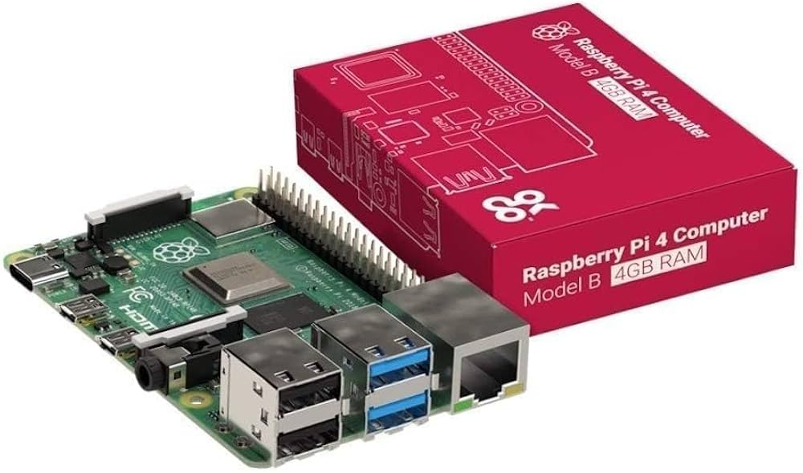

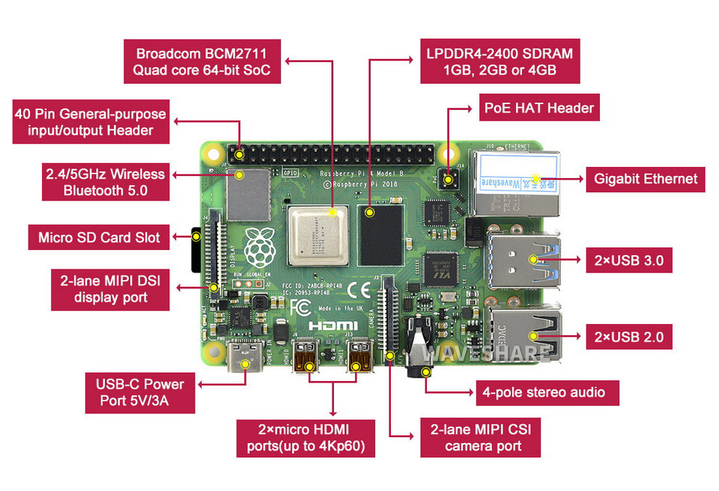

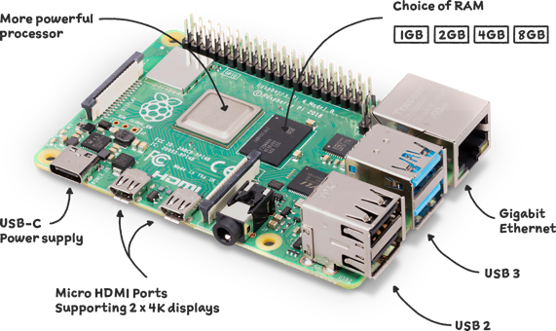

1. Case with Fan

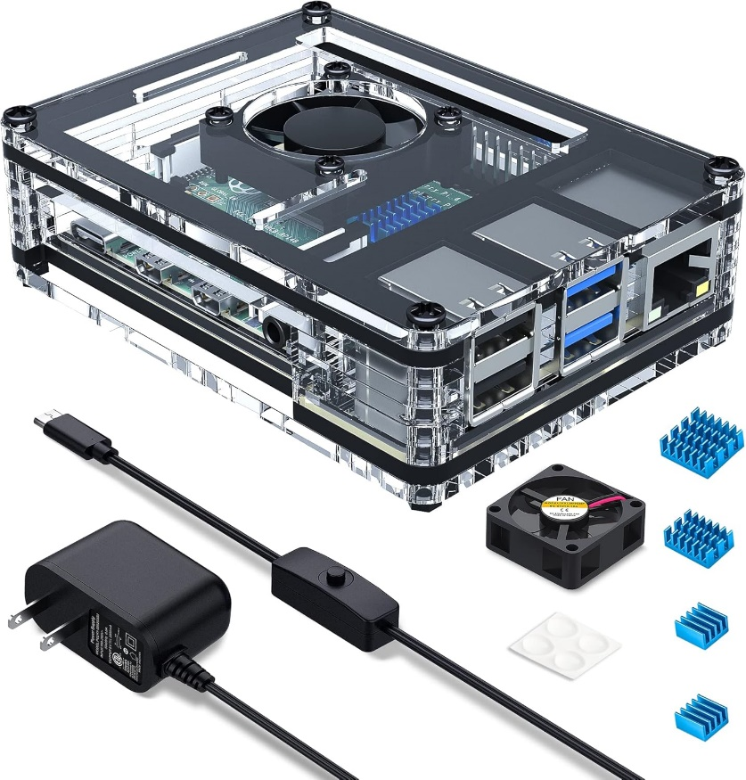

1. Micro HDMI to HDMI adapter

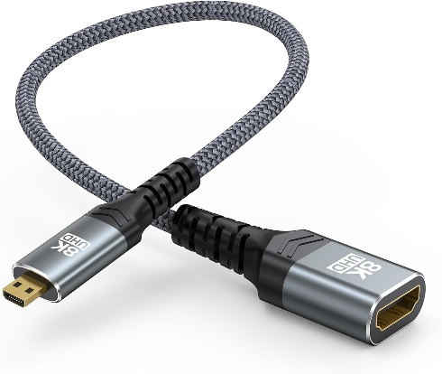

1. MicroSD Card

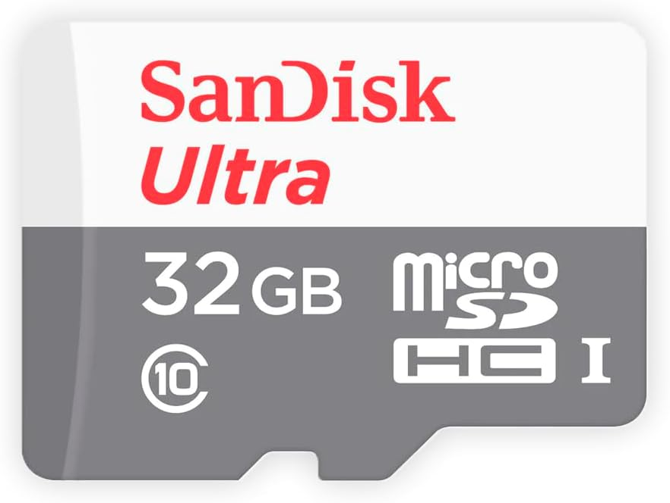

**Installation and Connection Instructions**

Assemble the Raspberry Pi and display according to the manufacturer's instructions.